ASSESSMENT TOOL 2

Case study

COURSE NAME: OBJECT ORIENTED ANALYSIS AND DESIGN

COURSE CODE: CSA11

COURSE OUTCOME COVERED

CO3: Analyze system requirements using object-oriented techniques to identify classes,

attributes, and relationships and develop use case models. (BL4)

Assessment Tool Weightage: 40%

Code of Conduct:

I N.Murali Sai (192372309) certify that this submission is my original work

and that I have adhered to the guidelines specified for this assessment.

I understand that any violation of academic integrity rules will result in disciplinary action.

Signature of the student:

Case Study 1: Online Hotel Reservation System
Application of Object-Oriented Principles
- Encapsulation: Each class hides its internal state behind well-defined methods — e.g. the Room class keeps 'price' and 'available' as private attributes, exposing only checkAvailability() so external code cannot corrupt booking data directly; Payment similarly hides transaction details behind processPayment().
- Inheritance: Customer, HotelManager, and Administrator all extend a common abstract User class that holds shared attributes (userId, name, email) and shared behaviour (login/logout), avoiding duplicated code across the three roles.
- Polymorphism: A generic notifyUser() or generateReport() method can be defined in the User hierarchy and overridden differently by Customer (booking confirmation), HotelManager (occupancy report), and Administrator (transaction audit report) — the system calls the same method name but gets role-specific behaviour at runtime.
Identified Classes and Relationships
Key classes: User (abstract), Customer, HotelManager, Administrator, Hotel, Room, Booking, Payment, Review. Hotel aggregates Room (1..*); Customer makes Booking (1..*) which associates to one Room and one Payment; Customer writes Review for a Hotel.
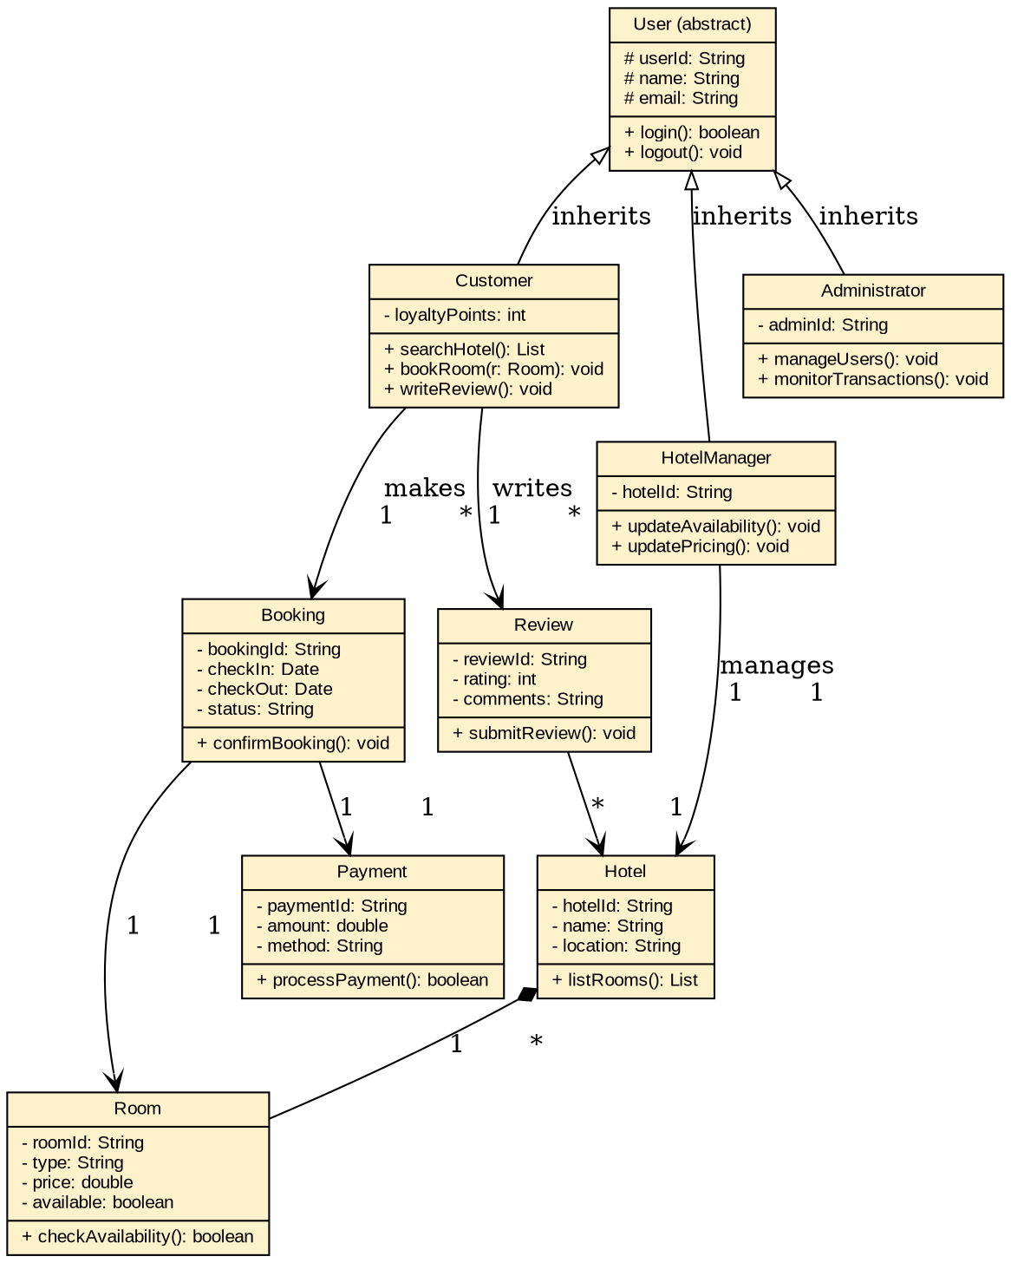
Figure 1: Class Diagram — Online Hotel Reservation System
Recommended SDLC Model: Incremental Model
The hotel reservation system has clearly separable functional modules — search, booking, payment, reviews, and admin management — that can each be built and released as working increments. The Incremental Model is well suited here because core booking functionality can be delivered early and used while payment gateways, review systems, and reporting dashboards are added in later increments, reducing time-to-market and allowing early user feedback to shape later increments, without the high overhead of continuous iteration that a purely Agile approach would need for a moderately well-understood, relatively stable set of requirements.

Case Study 2: University Management System
Structured Object-Oriented Approach
Requirements analysis identifies four distinct user roles (Student, Faculty, Examination Staff, Administrator) and four core academic entities (Course, Registration, Examination, Result) that interact through well-defined operations, following the standard OOAD approach of first identifying nouns (candidate classes) and verbs (candidate operations/relationships) from the requirement narrative.
- Encapsulation: Result keeps 'marks' private and only exposes calculateGrade(), preventing any component from setting a grade without going through the validated calculation logic.
- Inheritance: Student, Faculty, ExamStaff and Administrator all inherit common identity attributes and getDetails() from an abstract Person class, avoiding repeated attribute definitions.
- Polymorphism: A getDetails() call behaves differently for each subtype (a Student's details include program/roll number, a Faculty's include department) even though the calling code just invokes person.getDetails() uniformly.
Identified Classes and Relationships
Key classes: Person (abstract), Student, Faculty, ExamStaff, Administrator, Course, Registration, Examination, Result. Student creates Registration entries linked to Course; Faculty teaches Course; ExamStaff schedules Examination linked to Course; both Student and Examination relate to Result.
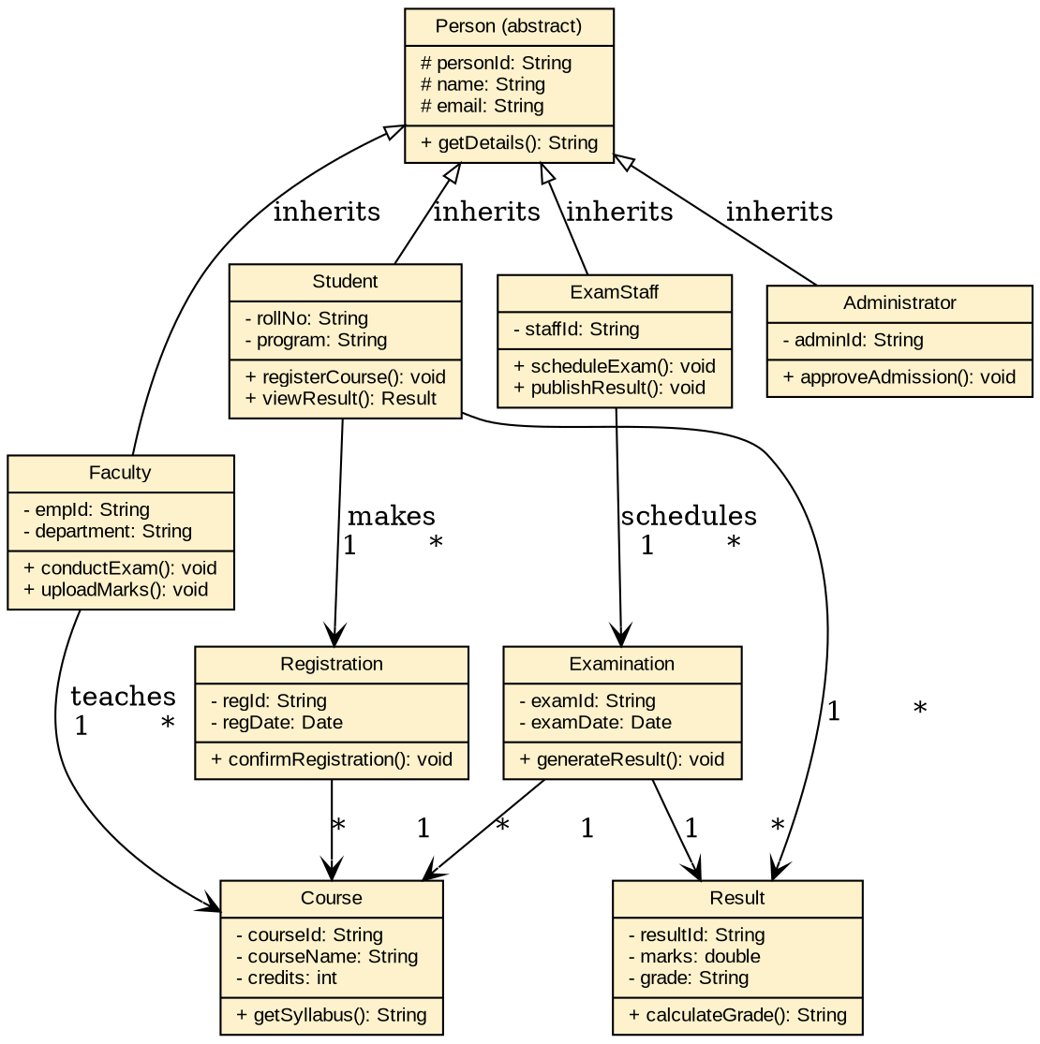
Figure 2: Class Diagram — University Management System
Recommended SDLC Model: Spiral Model
A university management system carries significant risk around data integrity (admissions, results) and must accommodate evolving academic regulations across departments. The Spiral Model is appropriate because it combines iterative development with explicit risk analysis at each cycle — each spiral (admissions module, course registration, examination and results) can be prototyped, evaluated for risk (e.g. data privacy, correctness of grade calculation), and refined before committing to the next phase, which suits a system that must remain correct and compliant while still evolving over multiple academic cycles.

Case Study 3: Online Retail Shopping Platform
Achieving Modular Design with Object-Oriented Techniques
Modularity is achieved by decomposing the platform into independent, loosely-coupled classes, each responsible for one concern: Product/Vendor handle catalog management, Order/Payment handle the purchase transaction, and Delivery handles fulfilment — each class can be developed, tested, and modified independently as long as its public interface (methods) remains stable, which is the essence of encapsulation-driven modularity.
- Encapsulation: Product hides 'stock' and 'price' behind getDetails(), so stock cannot be modified except through controlled vendor operations, preventing inconsistent inventory states.
- Inheritance: Customer, Vendor, and Administrator share a common User base class for authentication and identity, reducing duplicate login/logout logic across the platform.
- Polymorphism: A common 'generateReport()' or 'notify()' operation behaves differently when invoked on a Vendor object (catalog/sales report) versus an Administrator object (platform-wide transaction report), enabling uniform calling code with role-specific results.
Identified Classes and Relationships
Key classes: User (abstract), Customer, Vendor, Administrator, Product, Order, Payment, Delivery. Vendor aggregates Product (1..*); Customer places Order, which references multiple Product entries and links to one Payment and one Delivery.
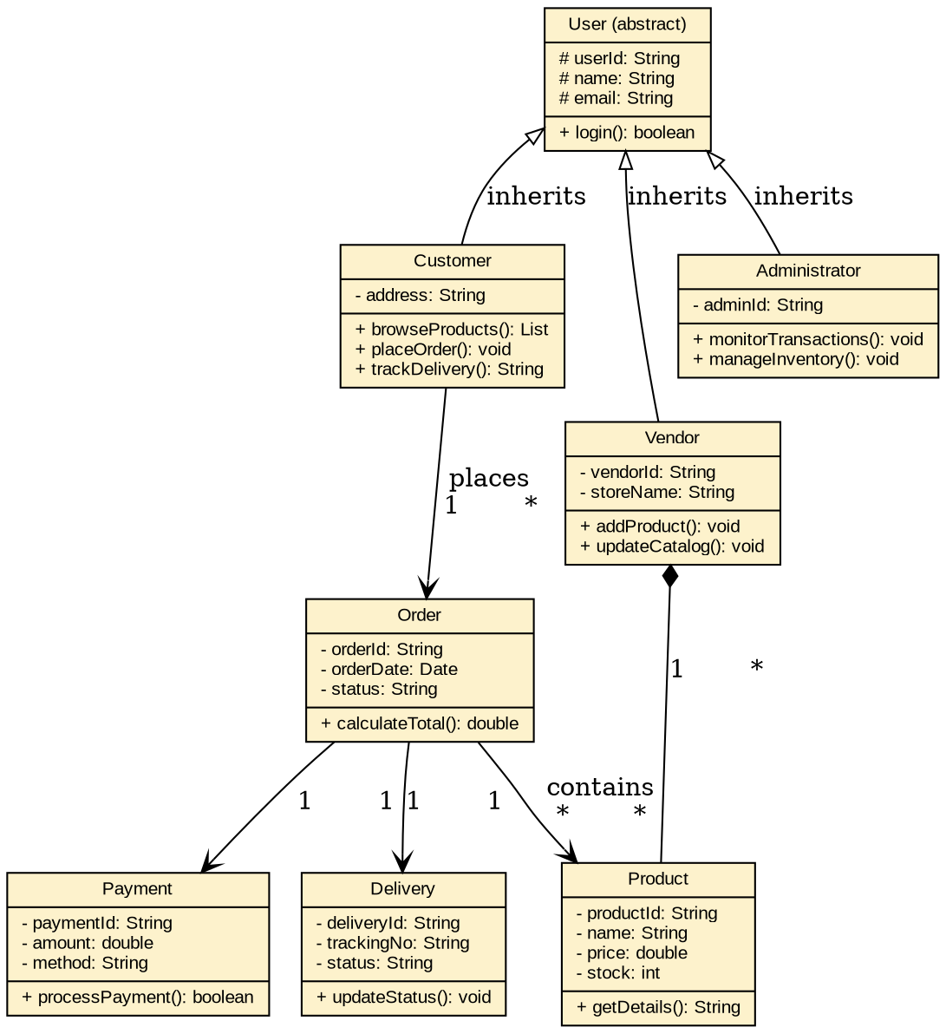
Figure 3: Class Diagram — Online Retail Shopping Platform
Evaluation of SDLC Models and Recommendation: Agile Model
- Waterfall — unsuitable: requires all requirements fixed upfront, but e-commerce platforms continually evolve (new payment methods, promotions, UI changes).
- Spiral — heavier than necessary here, since the platform does not carry the same regulatory/safety risk profile as healthcare or examination systems.
- Agile (Scrum) — best fit: retail platforms need frequent releases (new features, seasonal promotions, bug fixes) driven by changing customer and market feedback; Agile's short sprints and continuous stakeholder feedback loop directly match this need for speed and adaptability.
Recommendation: the Agile Model is most appropriate, allowing the catalog, ordering, payment, and delivery-tracking modules to be built and refined in short, customer-feedback-driven sprints.

Case Study 4: Smart Waste Management System
Object-Oriented System Development Principles
- Encapsulation: WasteBin hides its raw 'fillLevel' sensor reading and exposes only checkFillLevel() and sendAlert(), so external components (collection vehicles, dashboards) interact with a controlled interface rather than raw sensor data.
- Inheritance: An abstract Sensor class defines a common readData() operation; UltrasonicFillSensor inherits from it and provides the specific implementation for measuring bin fill depth — allowing future sensor types (e.g. weight sensors) to be added by extending Sensor without changing WasteBin's logic.
- Polymorphism: WasteBin can call sensor.readData() without knowing the concrete sensor type; if a different sensor technology is substituted later, WasteBin's code remains unchanged — a direct application of runtime polymorphism.
Identified Classes and Relationships
Key classes: Sensor (abstract), UltrasonicFillSensor, WasteBin, CollectionVehicle, Citizen, IssueReport, MunicipalStaff. WasteBin composes a Sensor and notifies CollectionVehicle when full; Citizen submits IssueReport, resolved by MunicipalStaff, who also assigns CollectionVehicle.
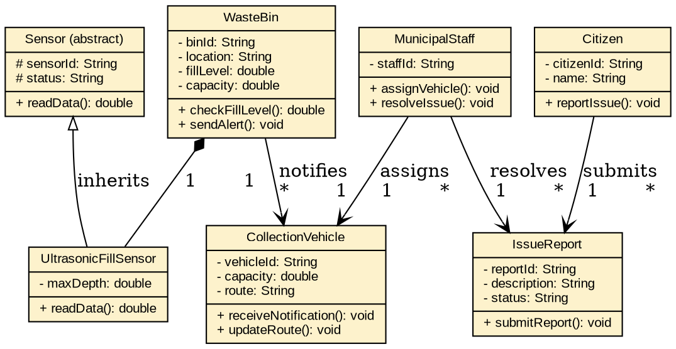
Figure 4: Class Diagram — Smart Waste Management System
Recommended Life Cycle Model: Agile / Iterative Model (with prototyping for IoT integration)
This system involves real-time sensor data, evolving IoT hardware integration, and requirements that are likely to change as the municipality learns from live deployment (e.g. sensor calibration issues, network reliability, new bin types). An Agile/Iterative model — optionally paired with an early prototyping phase to validate sensor-to-cloud connectivity — is best suited because it allows the system to be delivered in working increments (bin monitoring first, then vehicle notification, then the citizen reporting app), with each iteration incorporating feedback from real sensor behaviour, which a rigid sequential model like Waterfall cannot accommodate.

Case Study 5: Smart Healthcare Management System
Application of Object-Oriented Principles
- Encapsulation: MedicalRecord keeps 'diagnosis' details private, exposing only controlled updateRecord() operations restricted to authorized Doctor objects — protecting sensitive patient data from unauthorized modification, which is critical in a healthcare context.
- Inheritance: Patient, Doctor, and Administrator all inherit shared identity attributes (personId, name, contact) and getDetails() from a common abstract Person class, avoiding duplication while allowing each subtype to add role-specific attributes (e.g. Doctor adds 'specialization').
- Polymorphism: A generateReport() or notify() operation is overridden differently across Patient (appointment reminder), Doctor (patient list report), and Administrator (department/billing report), so the same method call produces role-appropriate output.
Identified Classes and Relationships
Key classes: Person (abstract), Patient, Doctor, Administrator, Appointment, MedicalRecord, Prescription, Billing. Patient books Appointment with Doctor; Doctor updates MedicalRecord and issues Prescription for a Patient; Patient is linked to Billing records.
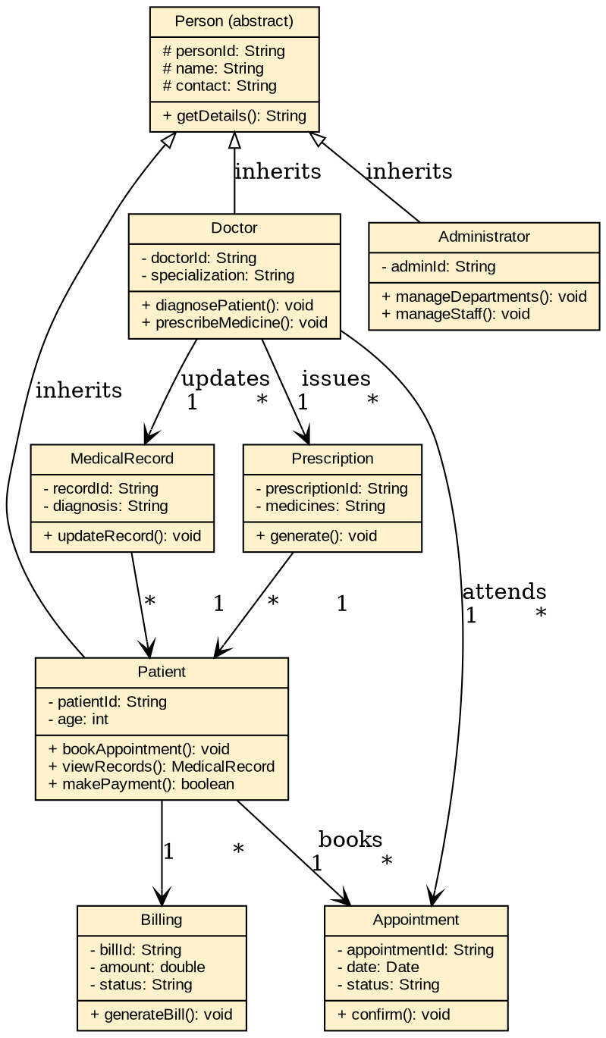
Figure 5: Class Diagram — Smart Healthcare Management System
Recommended SDLC Model: Spiral Model
Healthcare systems carry high risk around patient safety, data privacy (medical records), and regulatory compliance, while also needing iterative refinement as clinical workflows are validated with real doctors and patients. The Spiral Model is the most appropriate choice because it embeds explicit risk analysis into every development cycle — each spiral (appointment booking, medical records, billing) is prototyped, risk-assessed (e.g. data security, diagnosis-accuracy safeguards), and reviewed with stakeholders before the next iteration, which is essential for a system where errors have direct patient-safety consequences.

Case Study 6: Smart Library Management System
Structured Object-Oriented Solution
- Encapsulation: BorrowRecord keeps 'dueDate' and 'returnDate' private, exposing only calculateFine() so fine calculation logic is centralized and cannot be bypassed by external code.
- Inheritance: Member, Librarian, and Administrator all inherit common identity attributes from an abstract Person class, while Member itself can further differentiate 'type' (student vs faculty) as an attribute rather than a separate hierarchy, keeping the model simple.
- Polymorphism: A common notify() operation behaves differently depending on the object it's called on — notifying a Member of an overdue book versus notifying a Librarian of low inventory — while calling code uses a single, uniform interface.
Identified Classes, Attributes and Relationships
Key classes: Person (abstract), Member, Librarian, Administrator, Book, BorrowRecord, Reservation, Fine. Member creates BorrowRecord entries for Book (with optional linked Fine when overdue) and can also create Reservation for unavailable titles; Librarian manages the Book inventory.
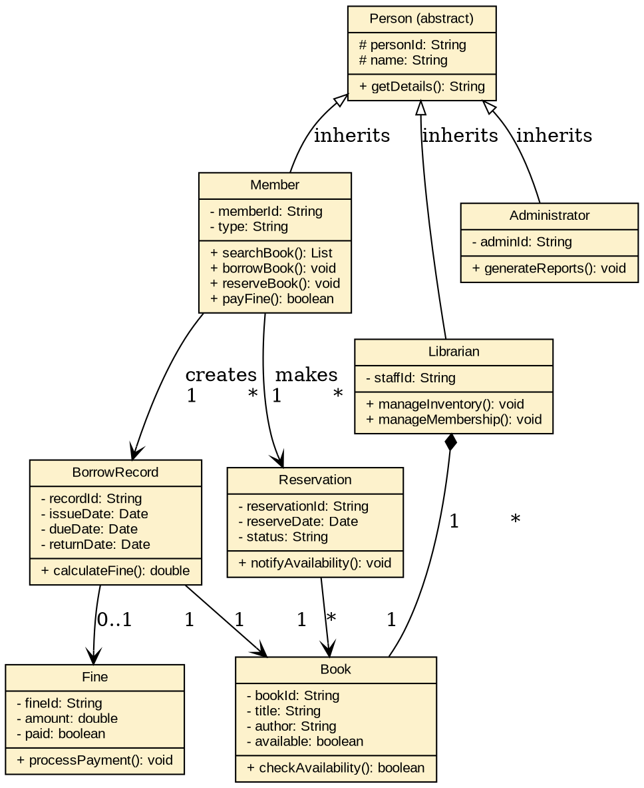
Figure 6: Class Diagram — Smart Library Management System
Recommended SDLC Model: Incremental Model
The library system's requirements are well understood and modular (search/catalog, borrowing/returning, online reservation, fine payment, reporting), making the Incremental Model the most efficient choice: the core borrow/return functionality can be delivered and used first, while online reservation and fine-payment modules are added as subsequent increments — giving the library working functionality early without the risk-management overhead the Spiral model would add for a comparatively low-risk, well-specified system.

